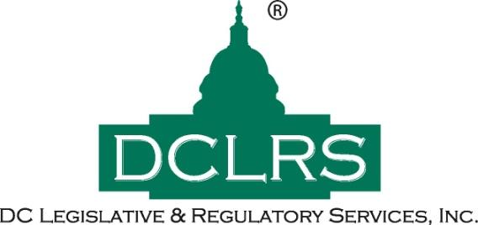

**June 2, 2020**

**To:**

**From: David Crow, Laurie-Ann Flanagan, David Beaudreau**

**Re: Webinar: 2 Months In – The CARES Act and Other COVID Relief**

On June 2, the Committee for a Responsible Federal Budget (CRFB) hosted a webinar titled “2 Months In – The CARES Act and Other COVID Relief,” to discuss the economic effects of the government’s spending efforts to stanch the economic recession caused in part by lockdown measures.

**Preliminary Brief:**

On March 27, 2020, the President signed into law the Coronavirus Aid, Relief, and Economic Security (CARES) Act, the most sweeping economic recovery law in generations. That law and others authorize a combined $3.6 trillion of support for the economy. Meanwhile, the Federal Reserve has announced nearly $6 trillion of loans, equity purchases, and other extraordinary economic interventions. And the executive branch has authorized further support as well. On June 2, the Committee for a Responsible Federal Budget (CRFB) began their webinar by discussing the timeline of Federal action taken to improve economic damage caused by the COVID pandemic (12-13% initial economic contraction resulting in 30 Million unemployed). Referencing data taken from the CRFB’s [COVID Money Tracker](http://www.crfb.org/project/covid-money-tracker) website, the Committee Senior Vice President and Policy Director Marc Goldwein discussed the efficacy of the CARES Act as well as future fiscal issues that will need to be addressed in light of the dramatic increase in spending.

**Initial Successes and Failures:**

While the CARES Act saw a rapid effort to address the fiscal issues at hand relative to most legislative processes –committing roughly $6 Trillion to immediate relief– the action taken was not realized by most for two weeks. After a slow start with the stimulus rebates, the Federal Reserve hit its stride in dispersing the committed funds, increasing the dispersion of unemployment benefits from $1 B/week in February to nearly $20 B/week in May, drawing from the $125 B allocated for these benefits. Whereas interest rates were rapidly reduced by over 0.5% on March 3rd and then again lowered to 0% shortly after, targeted lending programs have taken a much more gradual approach. Additionally, having signaled a willingness to spend up to $750 B in the bond market, the Federal Reserve was able to effectively stabilize that market via the strength of their credit, spending only $2-3 B in that area. The Federal Reserve has continued to purchase as much debt as the Treasury will issue along with roughly $2 Trillion mortgage-backed securities to ensure liquidity.

**Did It Work?:**

As a result of the passage of the CARES Act and the swift spending action taken by the Federal Reserve, the rate of increase of unemployment has decreased. Market income losses (which were down by 10% in April) have not only been replaced, but have also experienced rebounds of 3%. Of the roughly 75% of Small Businesses that applied for loans, 70% out of 75% of those loans have been approved, up from only 40% in May. Fifty-Seven percent of businesses now have at least one month of operations funding which will provide much needed breathing room so they can prepare for the future. However, most small businesses are still unable to rehire in masse due to residual perceptions of market volatility. Similarly, individuals have been apprehensive to spend their stimulus checks; most commonly using their rebates to pay rent, save, and spread out the supplemental income in preparation for the coming months. While this indicates budgets ought to be more balanced in the future, the stimulus checks are not making their way back into the market and into the pockets of struggling businesses. Marc Goldwein concluded that although fiscal policy alone cannot pull reverse the effects of a pandemic, it can see many through to the end of the fiscal year on July 1.

**What CARES Spending Means for the Future:**

Although some states prepared for economic recession better than others as evidenced by their rainy-day funds, states nationwide will face hundreds of billions in lost revenue, the effects of which will be actualized at the start of the new fiscal year. Debt projections modeled by data gathered through the COVID Money Tracker project estimate a 10% increase in debt due to the pandemic, a figure that will increase dramatically if left unaddressed. Touching on the repercussions of rewarding states which were ill-prepared for a recession via bailouts, while also acknowledging the necessity of recession-borrowing and spending in alignment with Modern Monetary Theory, Goldwein urged that money be spent smartly so as to minimize the long-term impacts caused by COVID, as well as the fiscal measures taken to address it.